Joel Atkinson
February 27, 2026
CSD430 Server Side Development
Assignment 9.2 Project Part 4

Updated JavaBean Code:
package beans;
import java.sql.*;
import java.util.ArrayList;
import java.util.List;
/* Joel Atkinson, February 27, 2026 CSD430 Server Side Development Assignment Part 4 UPDATED BEAN CODE
The purpose of this assignment is to create a database called CSD430 in SQL, then create a table (I chose U.S. states),
and populate that table with at least 5 data fields. From there create a JavaBean to pull the data from the database
which will be linked to the .jsp files in order to have a selection of a U.S. state and then to display the data of that
state in a table. In addition to this, also create an index.jsp file for this course as the landing page where all of our
assignments will be held. I went ahead and also created .css style sheets for both the index as well as the module 5/6
.jsp files. */
public class StatesBean {
private static final String JDBC_URL = "jdbc:mysql://localhost:3306/CSD430?useSSL=false&serverTimezone=UTC";
private static final String JDBC_USER = "student1";
private static final String JDBC_PASS = "pass";
private static final String JDBC_DRIVER = "com.mysql.cj.jdbc.Driver";
static {
try {
Class.forName(JDBC_DRIVER);
} catch (ClassNotFoundException e) {
e.printStackTrace();
}
}
private Connection getConnection() throws SQLException {
return DriverManager.getConnection(JDBC_URL, JDBC_USER, JDBC_PASS);
}
public static class StateOption {
public final int id;
public final String name;
public StateOption(int id, String name) {
this.id = id;
this.name = name;
}
}
public static class StateRecord {
public int id;
public String stateCode;
public String stateName;
public String capital;
public String region;
public Long population;
public Integer yearFounded;
}
public List<StateOption> getStateOptions() {
List<StateOption> options = new ArrayList<>();
String sql = "SELECT id, state_name FROM Joel_states_data ORDER BY state_name";
try (Connection conn = getConnection();
PreparedStatement ps = conn.prepareStatement(sql);
ResultSet rs = ps.executeQuery()) {
while (rs.next()) {
options.add(new StateOption(
rs.getInt("id"),
rs.getString("state_name")
));
}
} catch (SQLException e) {
e.printStackTrace();
}
return options;
}
public StateRecord getStateById(int id) {
String sql = "SELECT id, state_code, state_name, capital, region, population, year_founded " +
"FROM Joel_states_data WHERE id = ?";
try (Connection conn = getConnection();
PreparedStatement ps = conn.prepareStatement(sql)) {
ps.setInt(1, id);
try (ResultSet rs = ps.executeQuery()) {
if (rs.next()) {
StateRecord s = new StateRecord();
s.id = rs.getInt("id");
s.stateCode = rs.getString("state_code");
s.stateName = rs.getString("state_name");
s.capital = rs.getString("capital");
s.region = rs.getString("region");
long popVal = rs.getLong("population");
s.population = rs.wasNull() ? null : popVal;
int yf = rs.getInt("year_founded");
s.yearFounded = rs.wasNull() ? null : yf;
return s;
}
}
} catch (SQLException e) {
e.printStackTrace();
}
return null;
}
public List<StateRecord> getAllStates() {
List<StateRecord> states = new ArrayList<>();
String sql = "SELECT id, state_code, state_name, capital, region, population, year_founded " +
"FROM Joel_states_data ORDER BY state_name";
try (Connection conn = getConnection();
PreparedStatement ps = conn.prepareStatement(sql);
ResultSet rs = ps.executeQuery()) {
while (rs.next()) {
StateRecord s = new StateRecord();
s.id = rs.getInt("id");
s.stateCode = rs.getString("state_code");
s.stateName = rs.getString("state_name");
s.capital = rs.getString("capital");
s.region = rs.getString("region");
long popVal = rs.getLong("population");
s.population = rs.wasNull() ? null : popVal;
int yf = rs.getInt("year_founded");
s.yearFounded = rs.wasNull() ? null : yf;
states.add(s);
}
} catch (SQLException e) {
e.printStackTrace();
}
return states;
}
public boolean addStateRecord(String stateName,
String stateCode,
String capital,
String region,
Long population,
Integer yearFounded) {
String sql = "INSERT INTO Joel_states_data " +
"(state_name, state_code, capital, region, population, year_founded) " +
"VALUES (?, ?, ?, ?, ?, ?)";
try (Connection conn = getConnection();
PreparedStatement ps = conn.prepareStatement(sql)) {
ps.setString(1, stateName);
ps.setString(2, stateCode);
ps.setString(3, capital);
ps.setString(4, region);
if (population == null) {
ps.setNull(5, Types.BIGINT);
} else {
ps.setLong(5, population);
}
if (yearFounded == null) {
ps.setNull(6, Types.INTEGER);
} else {
ps.setInt(6, yearFounded);
}
return ps.executeUpdate() == 1;
} catch (SQLException e) {
e.printStackTrace();
return false;
}
}
// Updated code for Part 4 of Project. Deletes a state record by primary key (id)
public boolean deleteStateById(int id) {
String sql = "DELETE FROM Joel_states_data WHERE id = ?";
try (Connection conn = getConnection();
PreparedStatement ps = conn.prepareStatement(sql)) {
ps.setInt(1, id);
int rows = ps.executeUpdate();
return rows > 0;
} catch (SQLException e) {
e.printStackTrace();
}
return false;
}
//Updated portion of Java Bean for Part 3 of assignment
public boolean updateStateRecord(int id,
String stateName,
String stateCode,
String capital,
String region,
Long population,
Integer yearFounded) {
String sql = "UPDATE Joel_states_data " +
"SET state_name = ?, state_code = ?, capital = ?, region = ?, population = ?, year_founded = ? " +
"WHERE id = ?";
try (Connection conn = getConnection();
PreparedStatement ps = conn.prepareStatement(sql)) {
ps.setString(1, stateName);
ps.setString(2, stateCode);
ps.setString(3, capital);
ps.setString(4, region);
// population is NOT NULL in your table, so don't allow null
ps.setLong(5, (population == null ? 0 : population));
if (yearFounded == null) {
ps.setNull(6, Types.INTEGER);
} else {
ps.setInt(6, yearFounded);
}
ps.setInt(7, id);
return ps.executeUpdate() == 1;
} catch (SQLException e) {
e.printStackTrace();
return false;
}
}
}

deleteState.jsp Code:
<%-- Joel Atkinson, February 27, 2026. CSD430 Server Side Development Assignment 9.2 Project part 4.
The purpose of this assignment is to build on the previous 3 with my states database. This week's project has me updating
my JavaBean and creating the new .jsp files to create the pages for the user to be able to delete a state from the database
and have the .jsp files pull the data through the JavaBean and delete the state data from the database and then
output the updated database information to the user in another .jsp page --%>
<%@ page contentType="text/html; charset=UTF-8" pageEncoding="UTF-8" %>
<%@ page import="beans.StatesBean" %>
<%@ page import="java.util.List" %>
<%@ page import="beans.StatesBean.StateRecord" %>
<%@ page import="beans.StatesBean.StateOption" %>
<!DOCTYPE html>
<html lang="en">
<head>
<meta charset="UTF-8">
<title>Delete State Record</title>
<link rel="stylesheet" href="assignment_5_1.css">
</head>
<body>
<div class="page">
<div class="header">
<h1>Delete State Record</h1>
<p>Select a state ID to delete. The table below shows all current records.</p>
</div>
<hr class="gold-divider">
<div class="content">
<%
StatesBean bean = new StatesBean();
List<StateRecord> states = bean.getAllStates();
List<StateOption> options = bean.getStateOptions();
%>
<div class="form-card">
<form action="processDeleteState.jsp" method="post">
<label for="id">Choose a record (by ID) to delete:</label>
<select name="id" id="id" <%= (options == null || options.isEmpty()) ? "disabled" : "" %>>
<%
if (options != null && !options.isEmpty()) {
for (StateOption o : options) {
%>
<option value="<%= o.id %>"><%= o.id %> - <%= o.name %></option>
<%
}
} else {
%>
<option>No records available</option>
<%
}
%>
</select>
<div class="button-row">
<button type="submit" <%= (options == null || options.isEmpty()) ? "disabled" : "" %>>
Delete Record
</button>
</div>
</form>
<table class="state-table">
<thead>
<tr>
<th>ID</th>
<th>State Name</th>
<th>State Code</th>
<th>Capital</th>
<th>Region</th>
<th>Population</th>
<th>Year Founded</th>
</tr>
</thead>
<tbody>
<%
if (states != null && !states.isEmpty()) {
for (StateRecord s : states) {
%>
<tr>
<td><%= s.id %></td>
<td><%= s.stateName %></td>
<td><%= s.stateCode %></td>
<td><%= s.capital %></td>
<td><%= s.region %></td>
<td><%= s.population %></td>
<td><%= s.yearFounded %></td>
</tr>
<%
}
}
%>
</tbody>
</table>
<div class="link-split">
<a class="link-button" href="index.jsp">Back to Index</a>
<a class="link-button" href="deleteState.jsp">Refresh List</a>
</div>
</div>
</div>
<hr class="footer-divider">
<div class="footer">
<p>© Joel Atkinson</p>
<p>Bellevue University</p>
<p>2026</p>
</div>
</div>
</body>
</html>

processDeleteState.jsp Code:
<%-- Joel Atkinson, February 27, 2026. CSD430 Server Side Development Assignment 9.2 Project part 4.
The purpose of this assignment is to build on the previous 3 with my states database. This week's project has me updating
my JavaBean and creating the new .jsp files to create the pages for the user to be able to delete a state from the database
and have the .jsp files pull the data through the JavaBean and delete the state data from the database and then
output the updated database information to the user in another .jsp page --%>
<%@ page contentType="text/html; charset=UTF-8" pageEncoding="UTF-8" %>
<%@ page import="beans.StatesBean" %>
<%@ page import="java.util.List" %>
<%@ page import="beans.StatesBean.StateRecord" %>
<%@ page import="beans.StatesBean.StateOption" %>
<!DOCTYPE html>
<html lang="en">
<head>
<meta charset="UTF-8">
<title>Delete State Record</title>
<link rel="stylesheet" href="assignment_5_1.css">
</head>
<body>
<div class="page">
<div class="header">
<h1>Delete State Record</h1>
<p>Record deletion results and remaining records are shown below.</p>
</div>
<hr class="gold-divider">
<div class="content">
<%
StatesBean bean = new StatesBean();
boolean deleted = false;
String message = "";
String idParam = request.getParameter("id");
int id = -1;
try {
id = Integer.parseInt(idParam);
deleted = bean.deleteStateById(id);
if (deleted) {
message = "Success! Record with ID " + id + " was deleted.";
} else {
message = "Error: Record could not be deleted (ID may not exist).";
}
} catch (Exception e) {
message = "Error: Invalid ID submitted.";
}
// Pull updated data
List<StateRecord> states = bean.getAllStates();
List<StateOption> options = bean.getStateOptions();
%>
<div class="form-card">
<p><strong><%= message %></strong></p>
<form action="processDeleteState.jsp" method="post">
<label for="id">Delete another record:</label>
<select name="id" id="id" <%= (options == null || options.isEmpty()) ? "disabled" : "" %>>
<%
if (options != null && !options.isEmpty()) {
for (StateOption o : options) {
%>
<option value="<%= o.id %>"><%= o.id %> - <%= o.name %></option>
<%
}
} else {
%>
<option>No records available</option>
<%
}
%>
</select>
<div class="button-row">
<button type="submit" <%= (options == null || options.isEmpty()) ? "disabled" : "" %>>
Delete Record
</button>
</div>
</form>
<table class="state-table">
<thead>
<tr>
<th>ID</th>
<th>State Name</th>
<th>State Code</th>
<th>Capital</th>
<th>Region</th>
<th>Population</th>
<th>Year Founded</th>
</tr>
</thead>
<tbody>
<%
if (states != null && !states.isEmpty()) {
for (StateRecord s : states) {
%>
<tr>
<td><%= s.id %></td>
<td><%= s.stateName %></td>
<td><%= s.stateCode %></td>
<td><%= s.capital %></td>
<td><%= s.region %></td>
<td><%= s.population %></td>
<td><%= s.yearFounded %></td>
</tr>
<%
}
}
%>
</tbody>
</table>
<div class="link-split">
<a class="link-button" href="deleteState.jsp">Back to Delete Page</a>
<a class="link-button" href="index.jsp">Back to Index</a>
</div>
</div>
</div>
<hr class="footer-divider">
<div class="footer">
<p>© Joel Atkinson</p>
<p>Bellevue University</p>
<p>2026</p>
</div>
</div>
</body>
</html>

Updated Index.jsp code to include Part 4:
<%@ page contentType="text/html; charset=UTF-8" pageEncoding="UTF-8" %>
<!DOCTYPE html>
<html lang="en">
<head>
<meta charset="UTF-8">
<meta name="viewport" content="width=device-width, initial-scale=1.0">
<title>CSD430 - Server Side Development</title>
<link rel="stylesheet" href="<%=request.getContextPath()%>/index.css">
</head>
<body>
<div class="page">
<div class="header">
<h1>CSD430 - Server Side Development</h1>
<p>This index page contains links to all module assignments for this course.</p>
</div>
<hr class="gold-divider">
<div class="content">
<h2>Assignments</h2>
<div class="assignments">
<ul>
<li>
<a class="assignment-link" href="selectState.jsp">
<span class="assignment-title">
Assignment Part 1 - State Database Lookup
</span>
<span class="assignment-desc">
State Record Display
</span>
</a>
</li>
<%-- Adding in link and description to my index page for Part 2 of Assignment --%>
<li>
<a class="assignment-link" href="addState.jsp">
<span class="assignment-title">
Assignment Part 2 - Add State Record
</span>
<span class="assignment-desc">
Insert New State Into Database
</span>
</a>
</li>
<li>
<a class="assignment-link" href="updateSelect.jsp">
<span class="assignment-title">
Assignment Part 3 - Update State Record
</span>
<span class="assignment-desc">
Update Existing State Record
</span>
</a>
</li>
<li>
<a class="assignment-link" href="deleteState.jsp">
<span class="assignment-title">
Assignment Part 4 - Delete State Record
</span>
<span class="assignment-desc">
Delete Existing State Record
</span>
</a>
</li>
</ul>
</div>
</div>
<hr class="footer-divider">
<div class="footer">
<p>© Joel Atkinson</p>
<p>Bellevue University</p>
<p>2026</p>
</div>
</div>
</body>
</html>

Screenshot of updated Index page:
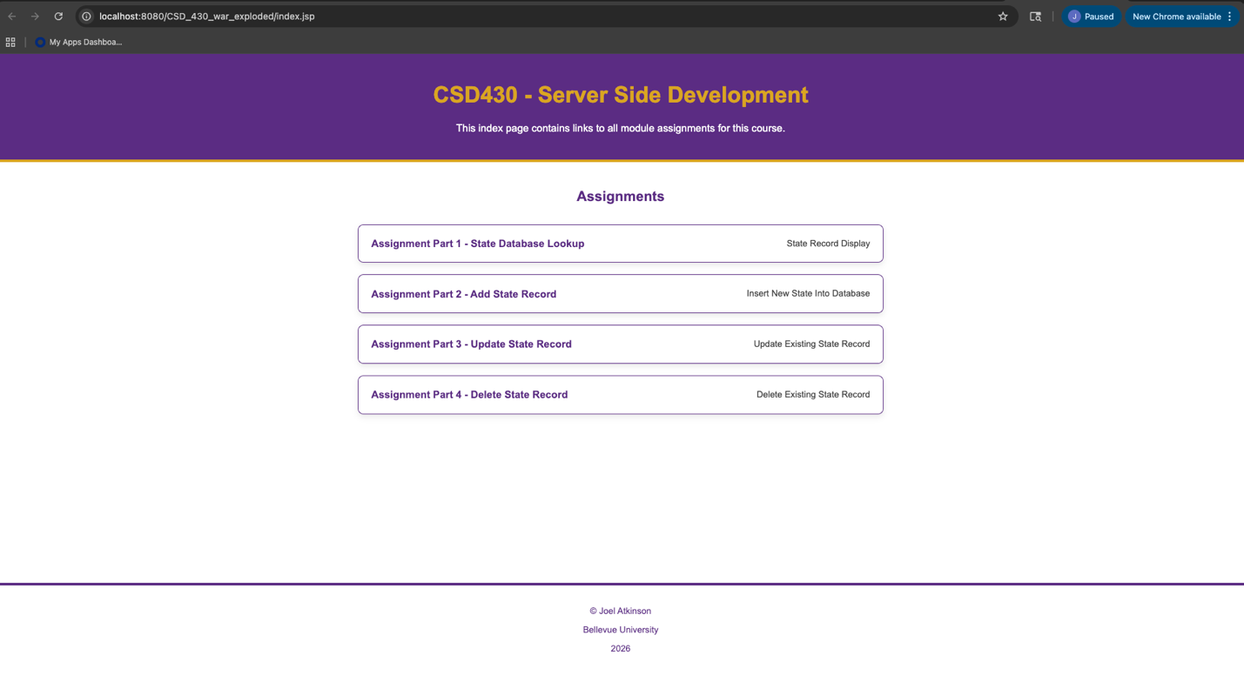
Screenshot of deleteState.jsp output and me deleting Alaska from the database:
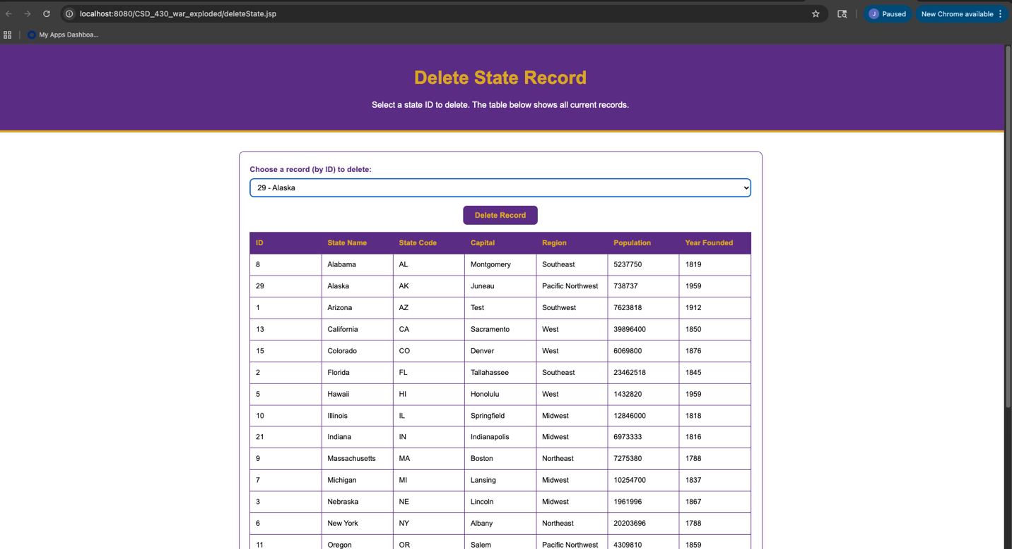
Screenshot of processDeleteState.jsp showing success and the updated data in the database without Alaska:
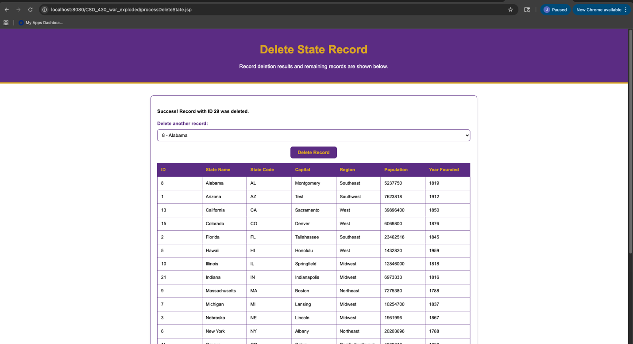
Screenshot of SQL database in Terminal to prove that JavaBean connected the database to the jsp file and Alaska was actually deleted:
